POCKETSMART AI
Project 1: Project Workflow
Introduction • Workflow • Color Diagram • Code • Explanation

1. Introduction
PocketSmart AI is a GenAI-powered budgeting and recommendation system designed to help users make better spending decisions. The system accepts a user's budget, category, and requirements, processes the request through a FastAPI backend, and sends the validated data to a recommendation engine. The engine analyzes the requirements and produces budget-aware recommendations. The final results are returned to the user through the application interface.
The Project Workflow topic explains how information moves through the system from user input to final recommendations. A clear workflow is important because it separates input handling, backend processing, AI logic, analysis, and result presentation into understandable stages.

2. Objectives
- Collect user budget, category, and requirement details.
- Validate incoming data before processing.
- Create a simple FastAPI backend workflow.
- Pass validated information to the AI recommendation module.
- Generate recommendations that consider the user's budget.
- Display the final result in a clear and useful format.

3. Project Workflow Diagram
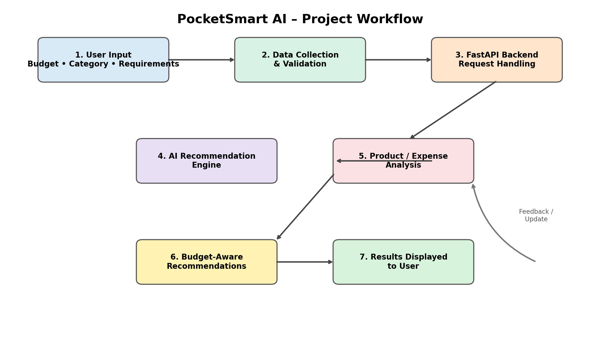

4. Workflow Explanation
Stage | Component | Explanation
1 | User Input | User enters budget, product/category, and requirements.
2 | Data Validation | The system checks whether required values are present and valid.
3 | FastAPI Backend | FastAPI receives the request and controls the application workflow.
4 | AI Recommendation Engine | The validated request is processed to generate relevant recommendations.
5 | Analysis | Products or expenses are compared against the user's needs and budget.
6 | Budget-Aware Result | Recommendations are filtered or prioritized according to the available budget.
7 | Result Display | The application returns the final recommendations to the user.

5. Sample FastAPI Workflow Code
The following sample demonstrates the basic backend workflow for Project 1. It is a starting-point implementation; the AI recommendation function can later be connected to an actual GenAI model or recommendation service.
from fastapi import FastAPI
from pydantic import BaseModel

app = FastAPI(title="PocketSmart AI")

class BudgetRequest(BaseModel):
budget: float
category: str
requirement: str

def generate_recommendation(data: BudgetRequest):
# Replace this function with an actual AI/GenAI model call.
return {
"category": data.category,
"budget": data.budget,
"requirement": data.requirement,
"recommendation": (
f"Find options in {data.category} within "
f"a budget of {data.budget} for: {data.requirement}"
)
}

@app.get("/")
def home():
return {"message": "PocketSmart AI is running"}

@app.post("/recommend")
def recommend(data: BudgetRequest):
# 1. Receive user input
# 2. Validate input using Pydantic
# 3. Send validated data to recommendation engine
# 4. Return result to the user
return generate_recommendation(data)

6. Code Explanation
FastAPI: Creates the web API that receives and processes application requests.
BudgetRequest: A Pydantic model that defines the expected input: budget, category, and requirement.
generate_recommendation(): Represents the AI/recommendation layer. It can later be connected to an LLM or recommendation model.
/: A simple health/home endpoint used to confirm that the backend is running.
/recommend: POST endpoint that receives the user's data and returns the recommendation result.

7. Example Input and Output
Example JSON request:
{
"budget": 5000,
"category": "Home Decor",
"requirement": "Modern study table"
}
Example response:
{
"category": "Home Decor",
"budget": 5000,
"requirement": "Modern study table",
"recommendation": "Find options in Home Decor within a budget of 5000 for: Modern study table"
}

8. Benefits of the Workflow
- Provides a clear separation between frontend input, backend processing, and AI logic.
- Makes the application easier to test and maintain.
- Allows the recommendation engine to be replaced or upgraded independently.
- Supports future integration with product APIs, databases, and GenAI services.
- Keeps the user's budget as an important input to the recommendation process.

9. Conclusion
The PocketSmart AI Project Workflow provides a structured path from user requirements to budget-aware recommendations. FastAPI acts as the backend layer, while the recommendation engine performs the intelligent processing. This modular workflow can be extended with real product data, authentication, databases, external APIs, and a production GenAI model.

